Project Report:

**Health Care Data Management Dashboard**

**Name** – Aniket Nitin Mahadik

**Project Title** – health care data management

**Date** – 28oct 2024

**Technology** – Power Bi

**Tools- power bi visualization tools**

**Project Overview**

The Health Care Data Management Dashboard project is designed to analyze and visualize key healthcare metrics, including bed occupancy rates, patient feedback for doctors, and insurance-related financial data. The dashboards provide valuable insights for healthcare administrators, enabling them to monitor occupancy trends, manage patient care feedback, and assess financial aspects related to billing and insurance claims.

**Key Objectives:**

1. To monitor and analyze bed occupancy by type (Private, General, and ICU) and patient diagnosis.
2. To track patient feedback volume for doctors to assess the quality of care.
3. To compare billing and insurance amounts across different diagnoses for cost analysis.

**Dashboard Analysis**

**1. Dashboard 1: Bed Occupancy and Doctor Feedback Volume**

**Bed Occupancy**

* **Data Range**: From 5th December 2022 to 15th January 2023.
* **Occupancy Summary**:
  + **Private beds** have the highest occupancy, with over 3,000 occupied beds.
  + **General beds** follow, with about 2,000 occupied beds.
  + **ICU beds** have the lowest occupancy, with around 1,000 beds in use.
* **Insight**: The higher demand for private and general beds suggests a focus on inpatient care for non-critical cases, while ICU occupancy remains comparatively lower, likely for critical care patients.

**Doctor Feedback Volume**

* **Feedback Data**: Patient feedback is distributed equally across all listed doctors, each receiving approximately 4.83K feedback entries.
* **Doctors Analyzed**: The dashboard highlights seven doctors (Mark Joy, Jay Sinha, Jaya Yadav, Tejas Saxena, Niki Sharma, Naresh Goyenka, Ravi D) with an almost equal share in feedback volume.
* **Insight**: The balanced feedback volume suggests that patient appointments and interactions are well-distributed among the doctors, indicating balanced scheduling.

**2. Dashboard 2: Diagnosis-wise Bed Occupancy and Financial Analysis**

**Bed Occupancy by Diagnosis**

* **Diagnosis Summary**:
  + **Top Diagnoses**: Viral Infection (28%), Malaria (23.99%), and Typhoid (19.99%) are the leading causes of bed occupancy.
  + Other diagnoses such as Flu, Pneumonia, and Fractures occupy a smaller share of the bed capacity.
* **Insight**: This data indicates that infectious diseases are the primary reason for hospital admissions, highlighting a possible need for enhanced infection control and preventive care.

**Patient ID by Diagnosis**

* **Diagnosis Distribution**:
  + Viral infections and Flu represent the highest patient counts.
  + The distribution suggests that a significant percentage of hospital resources are allocated to managing infectious diseases.

**Health Insurance Amount vs Billing Amount by Diagnosis**

* **Financial Comparison**:
  + **Trend**: Insurance coverage generally aligns with billing amounts across diagnoses, although discrepancies exist for some conditions.
  + **Key Values**:
    - Viral Infection: ₹48M insurance vs. ₹35M billed.
    - Typhoid: ₹27M insurance vs. ₹30M billed.
    - Fracture: ₹7M insurance vs. ₹8M billed.
* **Insight**: The billing versus insurance trend shows that while most cases are covered well by insurance, certain conditions (like Typhoid and Fractures) may incur slightly higher costs than the insurance coverage, leading to out-of-pocket expenses for patients.

**Conclusion and Recommendations**

**Conclusion**

The dashboards provide a comprehensive overview of patient bed occupancy, feedback for medical staff, and financial data related to healthcare billing and insurance claims. The data highlights the hospital's focus on managing infectious diseases and balancing doctor workload while also identifying financial trends associated with healthcare insurance and billing.

**Recommendations**

1. **Resource Allocation**: Given the high occupancy for private and general beds, consider adjusting the bed distribution to meet patient demands better, particularly for non-critical cases.
2. **Infection Control**: With a significant portion of bed occupancy driven by infectious diseases, enhancing infection control measures could reduce future admissions.
3. **Financial Planning**: Address the billing vs. insurance gap for diagnoses like Typhoid and Fractures by reviewing insurance policies or negotiating better coverage terms with insurance providers.

* Dashboards:-
* PAGE NO.1

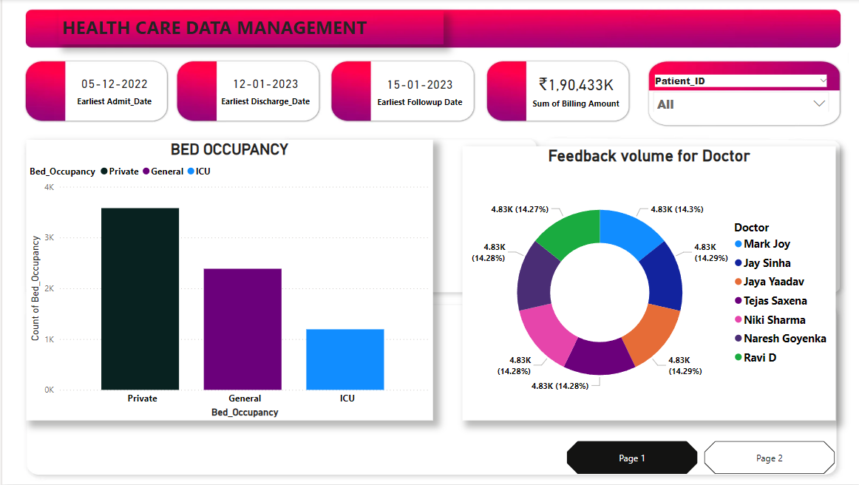

* PAGE NO.2

